

Let's look at Method 1633 versus other U. S. EPA PFAS methods. Method 8327 ([finalized July 2021](https://www.epa.gov/system/files/documents/2021-07/8327.pdf)) is intended for environmental aqueous matrices but is generally considered a screening-level method. Unlike Method 1633, 8327 utilizes direct injection rather than solid-phase extraction and does not include isotope dilution. The native analyte lists for EPA Methods 533, 537.1, and 8327 contain 25, 18, and 24 compounds respectively, significantly lower than the 40 native PFAS analytes covered by Method 1633. These differences highlight the comprehensive nature and low detection limits of Method 1633.

**Instrumentation**

* FMS EZPFC® System
* Vacuum pump
* Agilent 6475 TripleQuad LC/MS

**Consumables**

* Agilent Bond Elut PFAS WAX 150 mg cartridges (# 5610-2150)
* Ultrapure DI water
* Methanol pesticide grade
* Ammonium hydroxide
* Formic acid
* Relevant PFAS spiking standards

**Method**

* Twelve synthetic wastewater samples (500 mL) spiked with 50 ppt native PFAS standards and relevant internals
* Load sample bottles onto system and install cartridges
* Fill rinse bottles with 5 mL reagent water
* Turn on vacuum (stays on rest of procedure)

**Stage 1**

* Condition cartridges with 15 mL 1% methanolic ammonium hydroxide, followed by 5 mL of 0.3M formic acid.
* Load samples across the cartridges at 5-10 mL/min (~ 8-inch Hg)

**Introduction**

Significant strides have been made in the past few years in the tools available to assess and address the PFAS challenge. A mere three years ago, the U. S. Environmental Protection Agency (EPA) had yet to publish a method for PFAS in environmental samples such as groundwater and soils. This lack of a standardized method led to a complex and confusing process, with each laboratory developing and implementing its own specialized PFAS analytical methods. The convention of naming these methods after the EPA’s drinking water method 537 further added to the confusion. However, the development and validation of Method 1633 has significantly addressed these challenges, providing a standardized and reliable method for PFAS analysis, marking a crucial milestone in the field.

In January 2024 the EPA finalized the analytical method for environmental samples (also Method 1633). This application note is an overview of the validation of recent advancements in PFAS analytical methods, with a special focus on using the EZPFC Semi-Automated Solid Phase Extraction for Method 1633 in multiple water matrices. This development is crucial for all environmental scientists and professionals involved in PFAS analysis and environmental monitoring; the EZPFC provides a low-cost, high-throughput sample preparation workflow that produces the highest quality results, marking a new era in our understanding and management of PFAS contamination.

The EPA finally provided the long-awaited analytical method, [Method 1633](https://www.epa.gov/system/files/documents/2024-01/method-1633-final-for-web-posting.pdf), in draft form in August 2021. Since then, the EPA has published several updates as Method 1633 progressed through the evaluation/validation process. In January 2024, the final multi-laboratory validation steps were completed, and the 'draft' status was removed from Method 1633. Method 1633 is not just a tool, but a comprehensive solution designed to cover a wide range of PFAS sample matrices, including groundwater, surface water, wastewater, landfill leachate, soils, sediments, biosolids, and biological tissue. micrograms per kilogram (μg/kg) for solids, providing a high level of accuracy and reliability in our PFAS analysis.

*Application Note*

**Analysis of Per- and Polyfluoroalkyl Substances in Wastewater Using EPA Method 1633 with Semi-Automated Solid Phase Extraction**

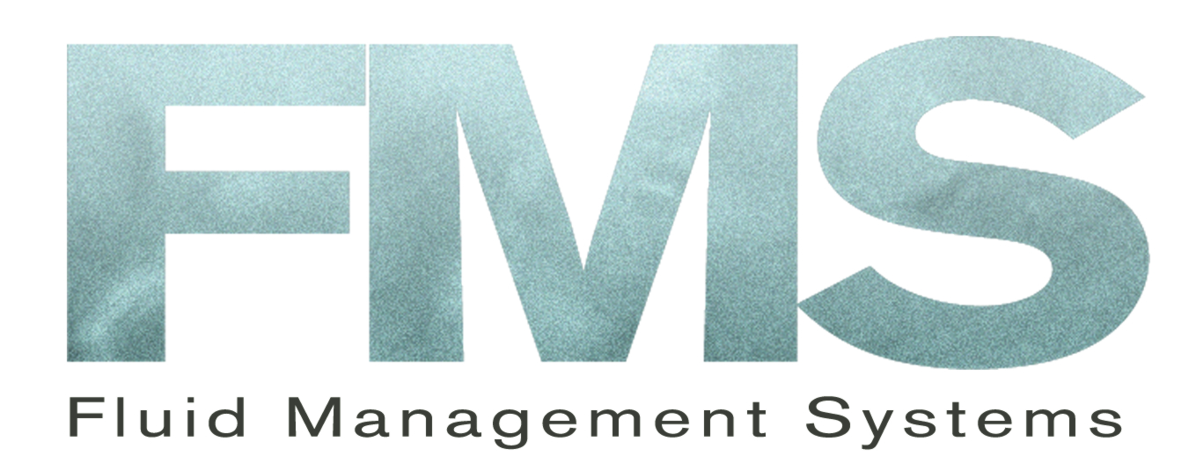



Agilent LC/MS system

* Sample bottles rinsed with 5 mL reagent water (twice), followed by 5 mL of 1:1 0.1M formic acid/methanol (using nitrogen)
* Rinses loaded across cartridges
* Dry 15 sec under vacuum

**Stage 2**

* Rinse sample bottles with 5 mL 1% methanolic ammonium hydroxide
* Load rinses across cartridges and collect in polypropylene tubes
* Cleanup carried out with 10 mg loose carbon
* As per the method no further concentration is carried out.
* Further relevant standards were added prior to LC/MS analysis.

**Analysis**

■ Take aliquot from final 5 mL extract (Method 1633 does not require volume reduction of final extract)

■ Agilent 1290 Infinity II LC System

■ Agilent 6475 Triple quad LC/MS

■ Agilent Zorbax Eclipse Plus C18 column 3.0 x 50 mm, 1.8 um

■ Column temperature 40 oC

■ Injection 5.0 uL

■ Mobile phase 5 mM ammonium acetate in 95% water, 5% acetonitrile (A) and methanol (B)

■ Gradient

0 min 98% A 2% B

0.2 min 98% A 2% B

10 min 5% a 95% B

■ Stop time 12.2 min

■ Dynamic MRM negative electrospray

■ T (gas) = 230 oC

■ T (sheath) = 355 oC

■ Negative capillary voltage: 2500 V

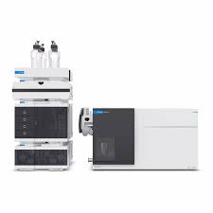

EZPFC System used for Method 1633



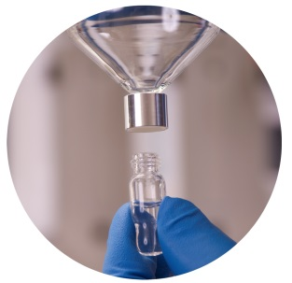

*Application Note*



*Application Note*

**Table 1**. Recoveries (%) and RSDs (%) for 40 native PFAS in synthetic wastewater (1633) using EZPFC (spiked with 1-38 ng/L).



**Table 2.** Recoveries (%) and acceptance windows (%) for 24 surrogate PFAS in synthetic wastewater (1633) using EZPFC.







*Application Note*

**Table 3.** Method Detection Limit values for 40 native PFAS in synthetic wastewater (1633) using EZPFC (spiked with 0.2-9 ng/L).

*Application Note*

**Table 5.** Native PFAS with EZPFC for method 1633 in river, well, and tap water (in ng/L).

**Table 4.** Native PFAS background with EZPFC for method 1633 (in ng/L).







*Note*

For more information, contact FMS:

FMS Inc.

900 Technology Park Drive

Billerica MA 01821

Phone: (617) 393-2396

Fax: (617) 393-0194

Email: [onlineinfo@fms-inc.com](mailto:onlineinfo@fms-inc.com)

Web site: www.fms-inc.com

**Discussion and Conclusions**

The EZPFC system demonstrates its efficiency by successfully analyzing all 40 native PFAS compounds using EPA method 1633 (Table 1) in twelve synthetic wastewater samples. The recoveries, well within the acceptance windows of the method with RSDs (%) all < 10%, further underline the system's reliability. Notably, the semi-automated system completes the process in under 70 minutes, without the need for a final concentration step, and consistently produces excellent recoveries with very good RSDs (%).

The EZPFC system's ability to produce excellent results is evident in the surrogate PFAS recoveries (%) and acceptance windows (%) shown in Table 2. Recoveries were consistently found well within those windows, further demonstrating the system's effectiveness and reliability.

Table 3 shows the method detection limits for all 40 native PFAS using synthetic wastewater. 32 out of 40 MDL values are < 0.50 ng/L.

The EZPFC system is designed with your analysis accuracy in mind. It boasts low native background values for PFAS, ensuring the precision of your results. Moreover, the system's low risk of cross-contamination, as demonstrated by Table 4, further enhances its cleanliness and precision. With about half of the native PFAS compounds being non-detectable and all values being < 0.03 ng/L, the system's reliability is underscored, giving you confidence in your results.

Table 5 analyzes three different water categories: river, well, and tap water. Good reproducibility was found between the replicates.

The EZPFC SPE system extracts 12 EPA 1633 samples in parallel delivering unprecedented throughput to your Sample Preparation Workflow.

The EZPFC system outperforms other, more expensive, fully automated SPE systems, providing you with superior data. Its user-friendly operation and simplified design minimize the risk of breakdown and contamination. Cleaning the system between runs is a breeze, further enhancing its practicality and efficiency.

A common challenge in ground- and wastewater extraction is the presence of particulate matter, which can easily lead to cartridge clogging. However, the EZPFC system has a solution. By incorporating stainless steel sample bottle filter and plastic filtration wool in the barrel of the cartridges, this issue is effectively eliminated. In our work, we observed no instances of cartridge clogging, underscoring the system's reliability and robustness.



*Application Note*

**Pressurized Liquid Extraction system**

1. Cells filled with hexane: DCM (50:50)
2. Cells pressurized to 1500 PSI
3. Cells heated to 120 ºC (2 cycles, 20 and 10 minutes)
4. Cells cooled to ambient temperature
5. Cells flushed with 20 mL solvent
6. Cells purged with N2 and extract discharged to SuperVap Concentrator.

**SuperVap concentration system**

1. Preheat temp: 20 minutes at 60 °C
2. Evap mode w/Sensor temp: 60 °C
3. Nitrogen Pressure: 10 PSI

**PowerPrep system**

1. Columns conditioned
2. Load sample extract(s)
3. Columns eluted with Hexane and collected (F1)
4. Alumina and Carbon columns eluted with DCM:Hexane and collected (F2)
5. Carbon column rinsed with ETAC:Ben (F3)
6. Carbon column back eluted with Toluene (F4)
7. Fractions F1, F2, F3 collected in a single vessel for the analysis of PCBs and PBDEs
8. Fraction F4 contains PCDDs, PCDFs and Co-Planar PCBs

